**Research Questions:**

1. **What are the aims and objectives of the application?**

* Do background research into why monitoring of app activity is necessary
* Include some statistics just for good measure
* Talk about existing solutions/existing technologies
* Talk a little about what the application is and what are the technologies used
* What features will the application have?
* What challenges will the app face and what are the solutions to it?

1. **Research existing solutions**

* Other phone applications (app monitoring/facial recognition)
* What does the app look like?
* How does it function?
* What is it missing?
* What can I add/What do I have they don’t?
* Have a grading table for the apps to highlight their strong and weak points

1. **Research the technologies of existing solutions (Could be apps or research papers etc.)**

* What OS do the apps use?
* What language can be used for machine learning?
* What libraries are used within these programming languages?
* What algorithms are used in machine learning to achieve the goal?
* What are some machine learning concepts/terminology?
* Talk about feature extraction.
* What are the datasets used in face tracking and emotion recognition?
* How to get machine learning on a mobile?
* How make an android service that monitors other apps?

1. **Design of prototypes**

* Use case diagrams
* ERD and database
* Mobile screens and buttons

**Interim Report Plan/Breakdown:**

**Abstract**

**1. Introduction**

* Project Challenges

**Project Background**

**Project Description**

**Project Aims and Objectives**

**Project Scope**

**Thesis Roadmap**

* Research
* Design
* Development
* Testing and Evaluation
* Redevelopment
* Conclusion and Future Work

**2. Literature Review**

* Introduction
* Alternate Existing Solution to Your Problem
* Conclusion

**Technologies You’ve Researched**

* Mobile Technology
* Databases
* API’s

**Dataset Research**

**Other Things You’ve Researched**

* Heuristics
* Accessibility
* Smart Design
* Data Privacy

**Existing Final Year Projects**

**Conclusions**

* Requirement Table

**3. Prototype Design**

* Introduction
* Software Methodology
* Overview of System
* Front-End
* Use Case Diagrams
* Flow Chart Diagrams
* Middle-Tier
* Back-End
* ERD
* Conclusions

**4. Prototype Development**

* Introduction
* Prototype Development
* Horizontal Prototype
* Front-End
* Middle-Tier
* Back-End
* Model Training
* Conclusions

**5. Testing and Evaluation**

* Introduction
* Plan for Testing
* Test Plan
* Unit Testing
* Integration Testing
* Black Box Testing
* Test Cases
* Plan for Evaluation
* Conclusions

**6. Issues and Future Work**

* Introduction
* Issues and Risks
* Project Weakness
* Plans and Future Work
* GANTT Chart

**Sample Roadmap:**

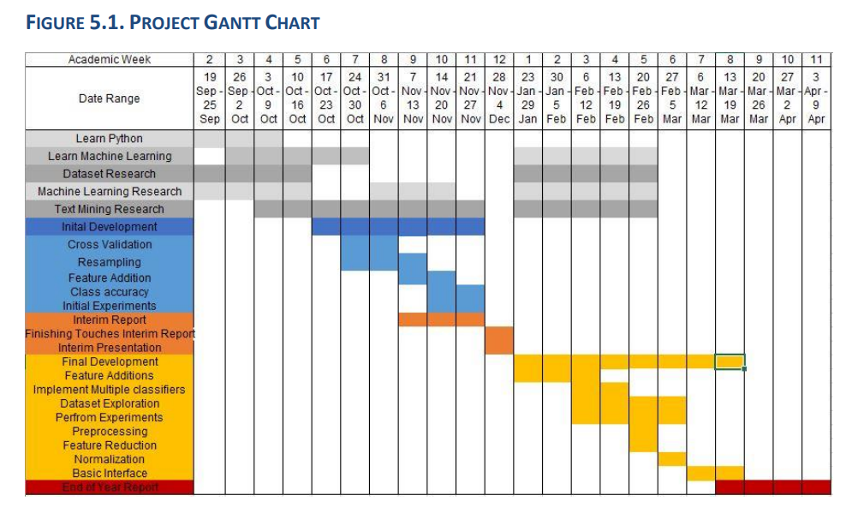

**Objectives for Week 4 (18th October):**

* Write Introduction part of the report
* Summary
* Overview
* Project Description
* Project Aims and Objectives
* Challenges
* Research existing solutions
* Research usability testing

**Objectives for Week 5 (25th October):**

* Write Literature Review part of the report
* Existing solutions
* Alternate existing solutions
* Technologies
* Other research
* Existing final year projects

**Objectives for Week 6 (1st November):**

* Write Prototype Design part of the report
* 3-tier architecture
* Software methodology
* Overview of system

**Objective for Week 7 (8th November):**

* Look up JustinMind prototype tool
* Write Prototype Development part of report
* 3-tier architecture

**Objective for Week 8 (15th November):**

* Write Prototype Development part of report
* 3-tier architecture

**Objective for Week 9 (22nd November):**

* Write Testing and Evaluation part of the report
* Plan for testing
* Plan for evaluation

Objective for Week 10 (29th November):

* Clean up Interim Report

**Sprint Plan**

**Week 6** (29/10/2020):

* Research existing implementations of Facial expression recognition
* Get the implementation with FastAI to work

**Week 7** (05/11/2020):

* Get existing solutions working with Keras. These solutions can be downloaded from GitHub.
* The solution that combined animated images and human images
* The solution which used the FER2013 architecture
* Research existing datasets

**Week 8** (12/11/2020):

* Better understand the existing solution and their architecture
* Design prototypes for the Usability side

**Week 9** (19/11/2020):

* Focus on the interim report document and organizing research up to this point
* Discuss the evaluation of the project and the emotion recognition
* Draw more prototype images/refine the prototype images
* Figure out to a great extent how the usability will be implemented

**Week 10** (26/11/2020):

* Begin the implementation of the usability testing.
* The simple data must be passed from the web app and the local application and vice versa.
* Implement a very basic front-end for the web application in the browser.

**Week 11** (03/12/2020):

* Implement the basic screen recording and camera recording.
* Attempt to process any data coming with the facial recognition model and save to the cloud.
* Display using basic text.

**Week 12** (10/12/2020):

* Finalize the work on the report and ensure the environment and the current state of the project is working as intended.

**Week 13** (17/12/2020):

**Alternate Existing Solutions:**

[**UserZoom GO**](https://go.userzoom.com/dashboard?workspace=76689)

* All in the browser
* Clean UI
* Moderated and Unmoderated study
* Interview and Usability Testing
* Test on own user/ $15 per response
* Desktop & Mobile
* With browser bar/without option
* Questions types: Text, Multiple Choice, Rating
* Starting URL & Includes wildcard
* Pre-study questions/ After task questions
* Success URL/Start task on new URL
* Cap screening responses
* Screen Questions
* Greetings
* Collect contact information
* Link is provided
* Team notifications
* Enable microphone in browser & includes microphone check
* Download extension for screen recording & select screen
* View video clips & give pass/fail to tasks
* Insights page for developer
* Pretty expensive but worth the money
* Provides free trial

[**UserTesting**](https://app.usertesting.com/dashboard#!/)

* UI is a bit cluttered, ironically. I don’t like the bar at the bottom that asks you if you are done
* Cannot view the results of user test without paying. Even the same one as a way to get familiar with the system
* An audience can be selected
* Select number of participants
* Select Device
* Filters such as (Age, Gender, Household income etc.)
* To review a test plan/ test an application has to be downloaded
* Instructions include:
* Starting URL
* Tell the user about the scenario they are in
* Tasks include (written instruction, 5 second test, verbal response, multiple choice, rating scale, written response)
* Testing users can be notified via email/slack
* Tests can be conducted on prototypes/websites/apps
* User’s are asked if they completed the task successfully with options to choose from

[**Loop11**](https://www.loop11.com/dashboard/reports/)

* Viewing videos was super slow
* The website was not working the entire time
* The UI is clean
* Browser extension has to be downloaded
* In depth statistics are being provided (Task success, task fail, task abandon, participants)
* Pie charts display data
* Shows participant demography (location, OS, device, browser)
* Shows task statistics (time to complete, success, fail, abandon)
* Videos can be downloaded (face, screen, combined)
* Video’s are low resolution in the sample example and do not load in the real test, also looks pretty bad
* Shows statistics on questions answered by users
* Each participant can be viewed (When they started tasks, how long it took, IP Address, Location, Device, OS, Browser). Each of their tasks and answers can be seen
* A Clickstream and Heatmap is provided. It looks kind of messy
* A project can be cloned
* Task creation format:
* Moderated & Unmoderated
* Screen recording, Face recording, Voice recording
* Task creation:
* Provide scenario
* Task types (Standard, Time Bound, First Click)
* Task can begin on image
* Options: Multiple choice, scale matrix, ranking question, open ended multiple choice, NPS, multiple choice with multiple answers, comment, System Usability Scale (SUS)
* Thank you message at end
* No. of participants, record URL parameters, Anonymise IP, Restrict IP
* Link to send to participants and pop up invitation with JavaScript code

Interim Report Step by Step:

Introduction (Overview)

* What is the focus (very brief)
* What is the problem/background (with statistics)

Project Description

* What is the project (once again)
* Talk about it in more detail on what it does
* Talk about complexity
* Talk about the end user and possibly testing the application on them and talk about how this is useful to the project
* Talk about the general approach of developing the software
* Include a screenshot of the prototype

Project Aims and Objectives

* What features/what objectives should have been met when you finished the project

Challenges

* What could be the potential problems
* What will need to be figured out for the project to be completed

Research

* Research papers and existing research into the area
* What problems this solves
* How is this project different

**Local Application & Videos**

[10 Reasons Why You Should Never Host Your Own Videos](https://www.wp101.com/10-reasons-why-you-should-never-host-your-own-videos/)

* Server Bandwidth
* File Size Limits and Storage Space
* Slow-Loading or Freezing Video
* No Single File Format Standard for Web Video
* Converting videos. A lot.
* Video Players
* Cumbersome Code
* Varying Quality Across Browsers

[How do you create a self-contained deep-learning executable?](https://www.reddit.com/r/deeplearning/comments/664lfp/how_do_you_create_a_selfcontained_deeplearning/)

[Deploying hybrid cloud storage with Swiftstack](https://cloud.google.com/solutions/partners/swiftstack-enables-hybrid-storage)

[Approaches to Deploying Machine Learning Models in Production](https://www.kdnuggets.com/2019/06/approaches-deploying-machine-learning-production.html)

[How/Where Do I store long videos on my website? There will be a lot of videos.](https://www.quora.com/How-Where-Do-I-store-long-videos-on-my-website-There-will-be-a-lot-of-videos)

* .

Video Storage and Streaming

* Swift Stack
* Microsoft Azure
* AWS
* StreamingVideoProvider
* Vimeo
* Muvi

**Facial Expression Recognition**

[Deep Learning Methods for Facial Expression Recognition](https://www.researchgate.net/publication/336927317_Deep_Learning_Methods_for_Facial_Expression_Recognition#:~:text=Abstract%20and%20Figures,convolutional%20neural%20network%20(CNN).)

[Facial Emotion Classification using Deep Learning](https://medium.com/analytics-vidhya/facial-emotion-classification-using-deep-learning-d08dd02a2d38)

[Human Facial Expression Recognition Using TensorFlow And OpenCV](https://www.researchgate.net/publication/343917291_Human_Facial_Expression_Recognition_Using_TensorFlow_And_OpenCV)

[Facial Expression Recognition with Keras Paid Tutorial](https://www.coursera.org/projects/facial-expression-recognition-keras?action=enroll&authMode=signup&isNewUser=true)

**Datasets**

**JAFFE (The Japanese Female Facial Expression (JAFFE) Dataset)**

* **Images**
* Images of the head
* 10 Japanese female expressers
* 213 images
* 256x256 pixels

**Emotic (EMOTions In Context)**

* **Images**
* Contains images of more than one person and scenes (activities people perform)
* 26 discrete categories, and the continuous dimensions valence, arousal, and dominance.
* 23,571 images
* 34,320 annotated people

**FEC (Google facial expression comparison dataset)**

* **CSV** (Download Image Links)
* Includes people performing activities and includes multiple people
* Provides coordinates of the face on the image
* 500,000 triplets
* 156,000 face images

**FER2013**

* **CSV** (Pixel values)
* 28,000 labelled images in the training set
* 3,500 labelled images in the development set
* 3,500 images in the test set
* seven emotions, such as happy, sad, angry, afraid, surprise, disgust, and neutral, with happy

**AffectNet** (Dataset requested)

* One of the largest datasets for facial affect in still images (1,000,000 Images)
* 440,000 manually annotated
* Both categorical and dimensional models.
* 1250 emotion-related tags
* Contains more than one million images with faces and extracted facial landmark points
* Seven discrete facial expressions (categorial model) and the intensity of valence and arousal

**FacesDB**

* **Images**
* 38 subjects, in other words 38 happy faces, 38 sad faces etc.

**FER Review:**

<https://medium.com/datadriveninvestor/real-time-facial-expression-recognition-f860dacfeb6a>

<https://github.com/gauravtheP/Real-Time-Facial-Expression-Recognition>

**Datasets:**

1. Human Images Source-1: <http://www.consortium.ri.cmu.edu/ckagree/>
2. Human Images Source-2: <http://app.visgraf.impa.br/database/faces/>
3. Human Images Source-3: <http://www.kasrl.org/jaffe.html>
4. Animated Images Source: <https://grail.cs.washington.edu/projects/deepexpr/ferg-db.html>

**Emotions:**

Angry, Disgusted, Fear, Happy, Neutral, Sad, Surprised

* Trained model on both animated images and human images
* Approximately 1500 human images and 9000 animated images
* Model trained with Keras and TensorFlow
* Images are read in from a folder of images, a folder for each image type (human/animated) and a folder for each expression type within that folder.

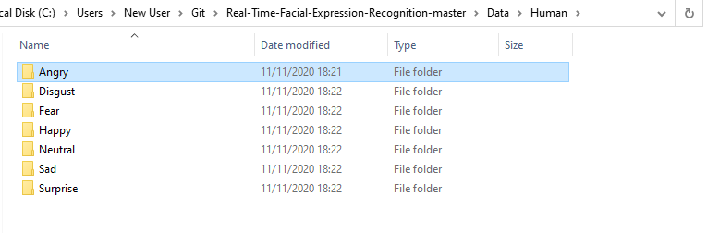

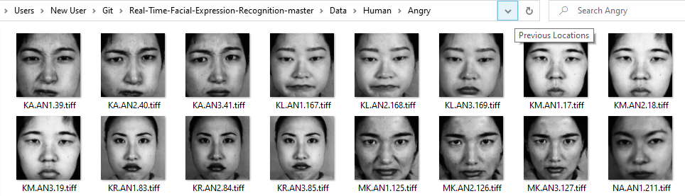

* DataFrames are created

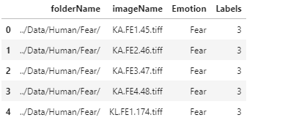

* Frames are concatenated and shuffled

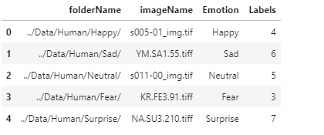

* Data is split within the program, pickled and saved to a file
* Bar chart displays data count

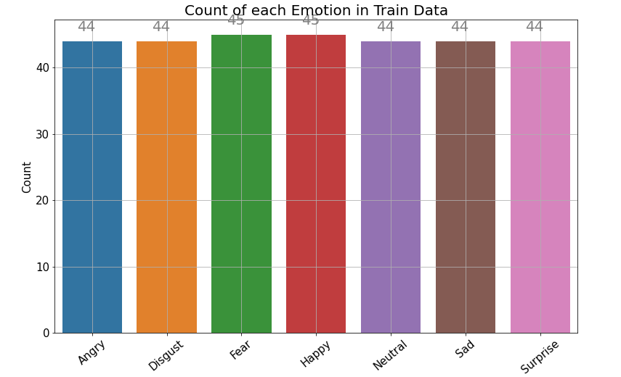

* Images are converted to grayscale before it is used to train the data
* Faces in the image are detected with HAAR, cropped and then saved
* Created bottleneck features from VGG-16 model (Transfer Learning)

**Java Backend Web Application**

[Java Hosting Service on Tomcat](https://javapipe.com/java-hosting/)

**Usability Testing**